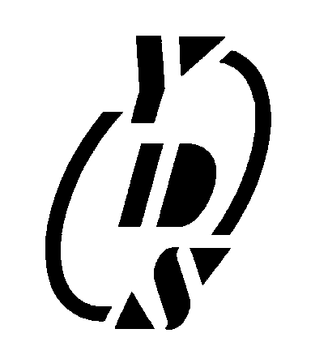 |  | 13D SERIES |  |  |  |  |  |  |  |  |  | 1000VDC SINGLE OUTPUT  1 WATT DC-DC CONVERTER
 | FEATURES |  |  |  |  |  |  |  |  |  | 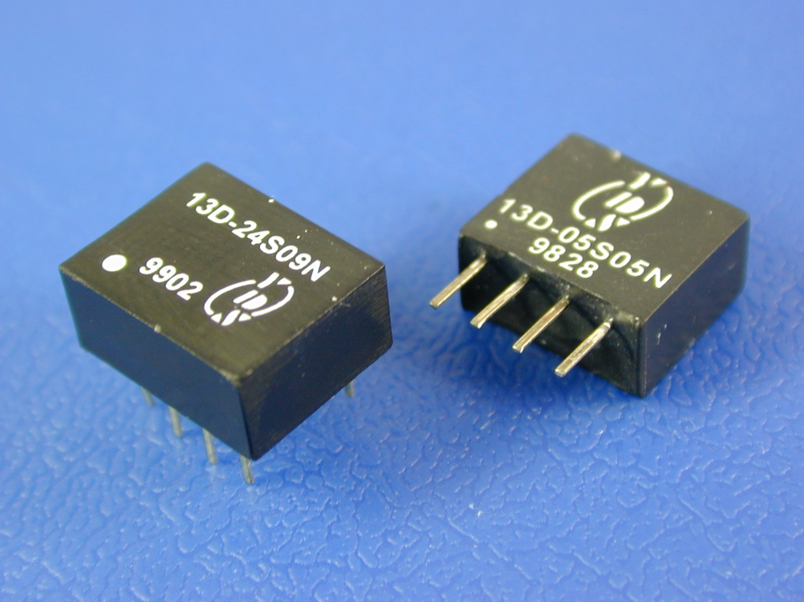
• 4 PIN SIP AND 8 PIN DIL PACKAGE.
• 1000VDC ISOLATION.
• UNREGULATED OUTPUT TYPES.
• UL 94V-0 PACKAGE MATERIAL.
 | GENERAL SPECIFICATIONS |  |  |  |  |  |  |  |  |  | ELECTRICAL SPECIFICATIONS
 | • OUTPUT RIPPPLE (20MHz Band limited) |  |  |  |  |  | : 150mVp-p MAX |  |  |  | • INPUT VOLTAGE RANGE |  |  |  |  |  | :±10%
 | • ISOLATION RESISTANCE |  |  |  |  |  | :1000MΩ MIN @500VDC |  |  |  | • OUTPUT VOLTAGE TOLERANCE |  |  |  |  |  | :±5%
 | • SWITHINGFREQUENCY |  |  |  |  |  | :100KHz TYP. |  |  |  | • LINE REGULATION(10% TO 100% F.L.) |  |  |  |  |  | :±1.2%/1% OF Vin
 | • OPERATING TEMPERATURE |  |  |  |  |  | :0 ℃ TO 70℃ |  |  |  | • LOAD REGULATION(10% TO 100% F.L.)
 | • ISOLATION VOLTAGE |  |  |  |  |  | :1000 VDC |  |  |  | 3.3V AND 5V OUTPUT TYPES |  |  |  |  |  | :15% MAX
 |  |  |  |  |  |  |  |  |  |  | 9V,12V AND 15V OUTPUT TYPES |  |  |  |  |  | :10% MAX
 | 3.3v,5V,12V,24V,48V input types
 | PART NUMBER |  | OUTPUT VOLTAGE  (VDC) |  | OUTPUT CURRENT  (mA) | EFFICIENCY  (% TYP.) |  |  | PACKAGE STYLE |  | PART NUMBER |  | OUTPUT VOLTAGE  (VDC) | OUTPUT CURRENT  (mA) |  | EFFICIENCY  (% TYP.) |  | PACKAGE STYLE
 | 13D-03S05N |  | 5 |  | 100 | 70 |  |  | 1 |  | 13D-03S05N3 |  | 5 | 100 |  | 70 |  | 3
 | 13D-03S09N |  | 9 |  | 56 | 75 |  |  | 1 |  | 13D-03S09N3 |  | 9 | 56 |  | 75 |  | 3
 | 13D-03S12N |  | 12 |  | 42 | 75 |  |  | 1 |  | 13D-03S12N3 |  | 12 | 42 |  | 75 |  | 3
 | 13D-03S15N |  | 15 |  | 34 | 75 |  |  | 1 |  | 13D-03S15N3 |  | 15 | 34 |  | 75 |  | 3
 | 13D-05S03N |  | 3.3 |  | 154 | 70 |  |  | 1 |  | 13D-05S03N3 |  | 3.3 | 154 |  | 75 |  | 3
 | 13D-XXS05N |  | 5 |  | 200 | 70 |  |  | 1 |  | 13D-XXS05N3 |  | 5 | 200 |  | 70 |  | 3
 | 13D-XXS09N |  | 9 |  | 110 | 75 |  |  | 1 |  | 13D-XXS09N3 |  | 9 | 110 |  | 75 |  | 3
 | 13D-XXS12N |  | 12 |  | 84 | 75 |  |  | 1 |  | 13D-XXS12N3 |  | 12 | 84 |  | 75 |  | 3
 | 13D-XXS15N |  | 15 |  | 67 | 75 |  |  | 1 |  | 13D-XXS15N3 |  | 15 | 67 |  | 75 |  | 3
 | 13D-48S05N2 |  | 5 |  | 200 | 70 |  |  | 2 |  | 13D-48S05N4 |  | 5 | 200 |  | 70 |  | 4
 | 13D-48S09N2 |  | 9 |  | 110 | 75 |  |  | 2 |  | 13D-48S09N4 |  | 9 | 110 |  | 75 |  | 4
 | 13D-48S12N2 |  | 12 |  | 84 | 75 |  |  | 2 |  | 13D-48S12N4 |  | 12 | 84 |  | 75 |  | 4
 | 13D-48S15N2 |  | 15 |  | 67 | 75 |  |  | 2 |  | 13D-48S15N4 |  | 15 | 67 |  | 75 |  | 4
 |  |  |  | 13D SERIES |  |  |  |  |  | 1000VDC SINGLE OUTPUT  1 WATT DC-DC CONVERTER
 | MARKINGS AND DIMENSIONS |  |  |  |  |  |  |  |  |  |  |  |  |  | PIN CONNECTION
 | 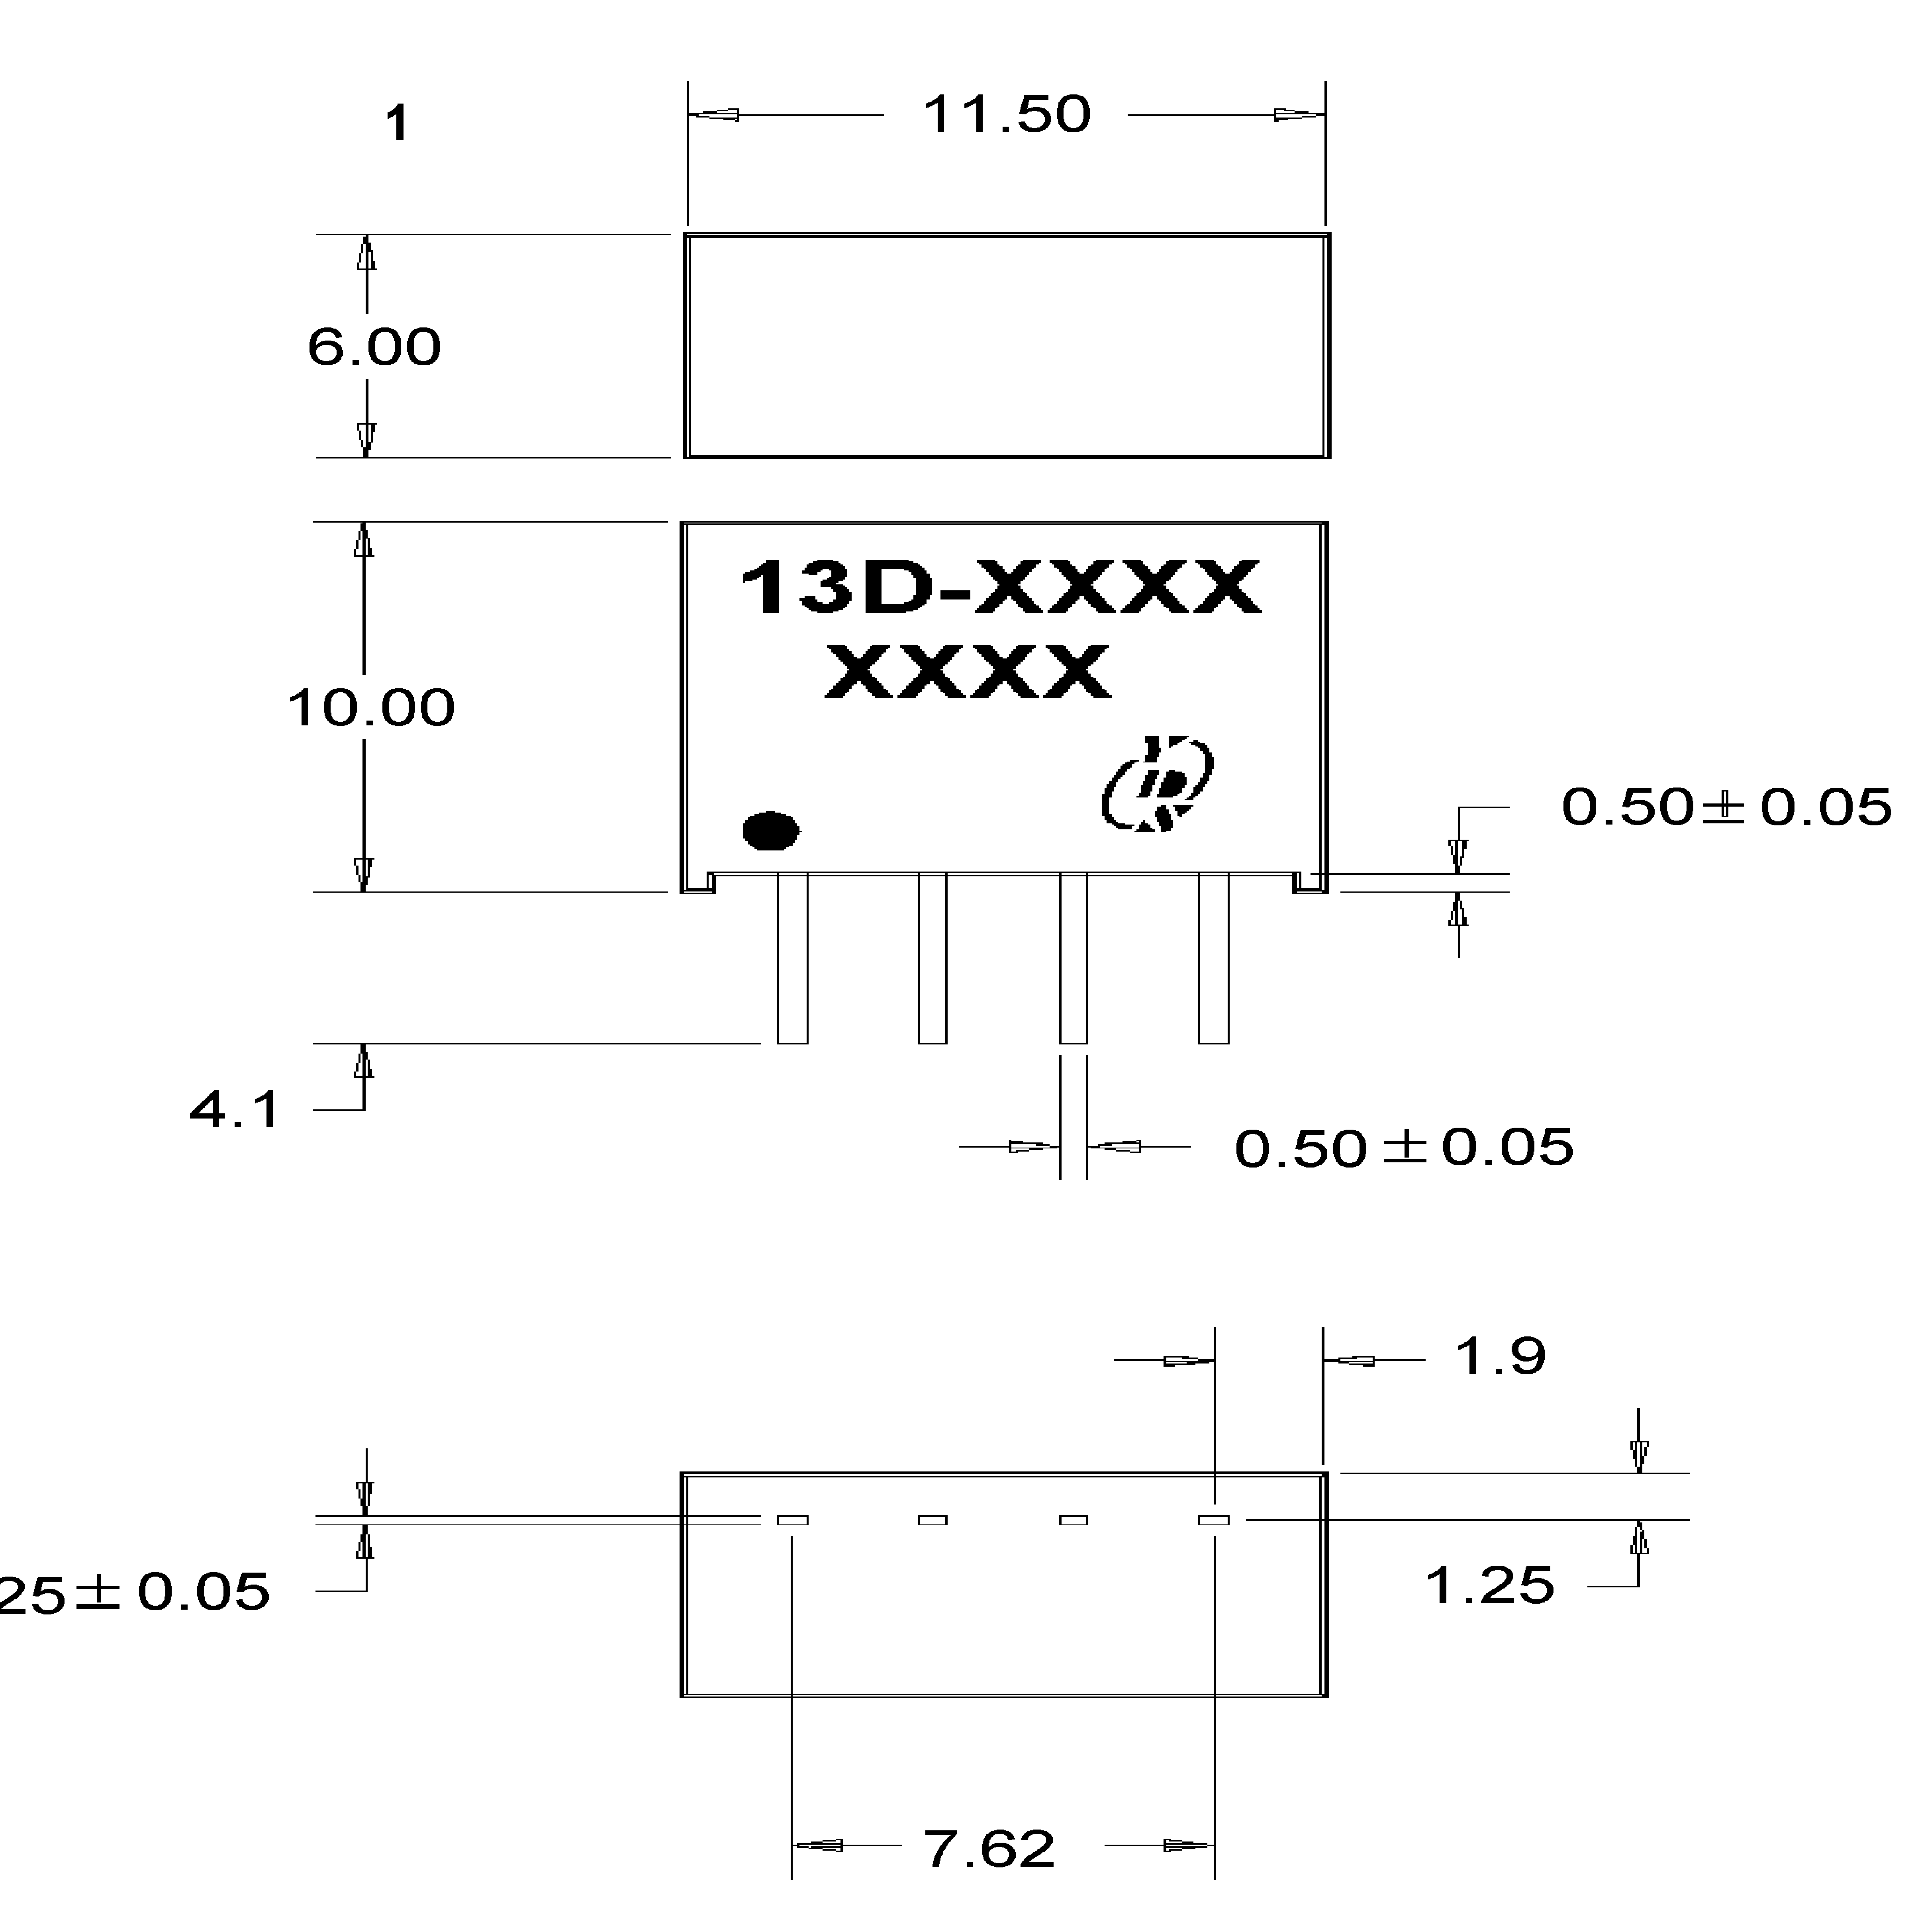 |  |  |  |  |  |  | 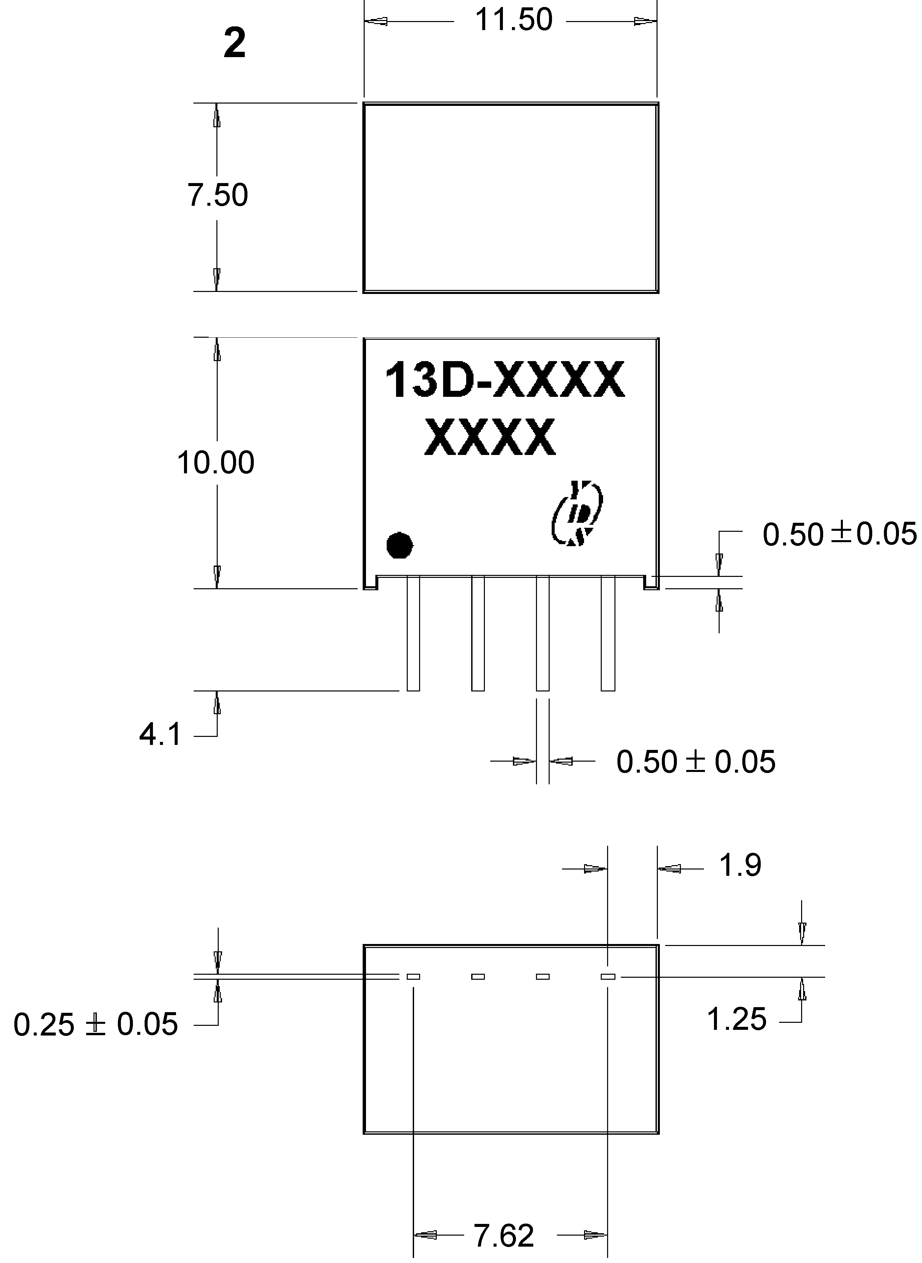
  PIN | 4 PIN
  1 | -INPUT
  2 | +INPUT
  3 | -OUTPUT
  4 | +OUTPUT

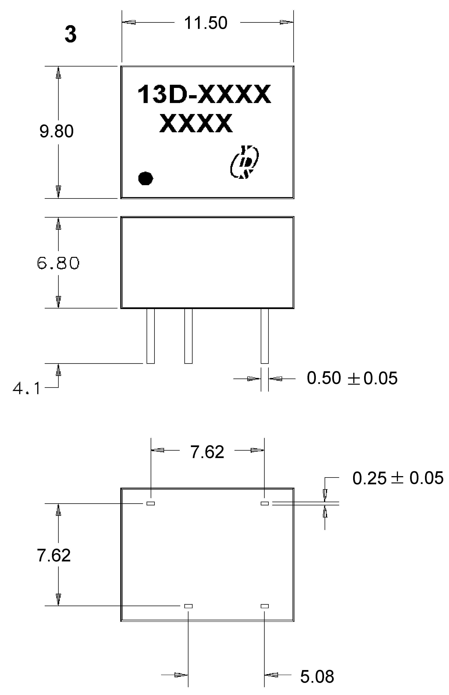  Dimensions:inches/mm  Unless otherwise specified,  all tolerances are±.005/±0.13 | 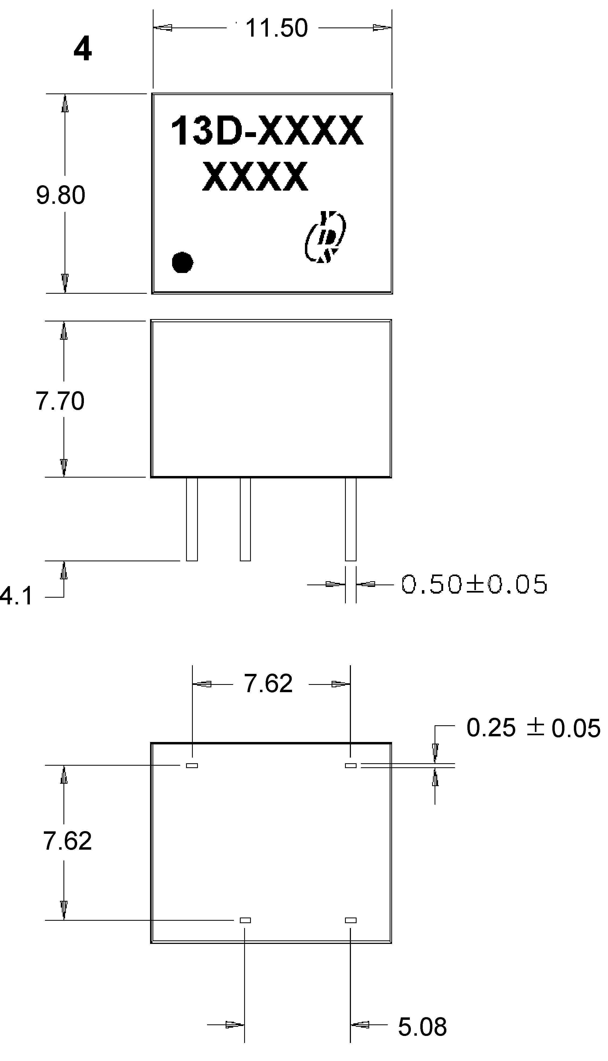
  PIN | 8 PIN
  1 | -INPUT
  4 | +INPUT
  5 | +OUTPUT
  7 | -OUTPUT

