西门子SIMATIC MV220紧凑型色标传感器
产品概述
SIMATIC MV220紧凑型色标传感器是一款用于彩色对象自动检测的完备的图像处理系统。MV220设计用于工业生产、包装应用以及食品和饮料工业应用。
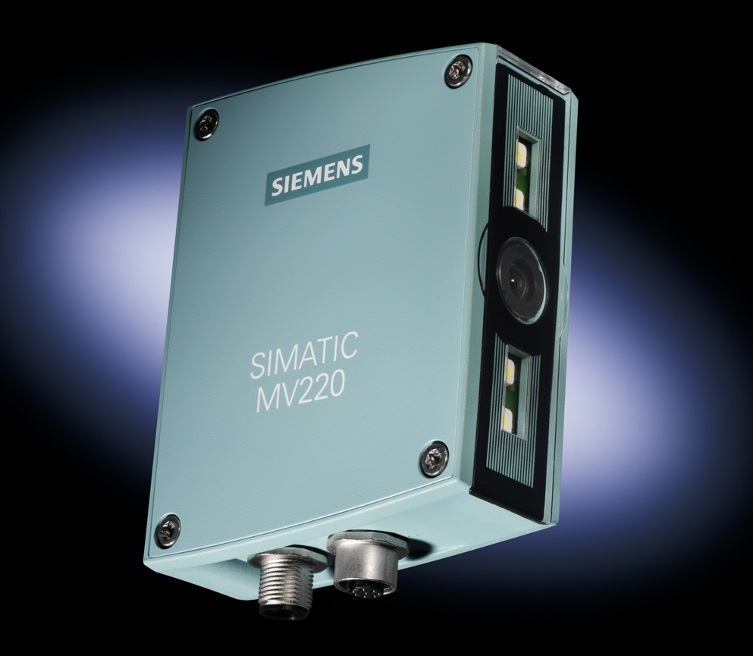
性能特点
●防护等级IP65，适合在恶劣的工业环境中安装。
●由于传感器检测时间短（每秒约进行30次检测），可控制高速加工过程。
●通过简单模型开关，切换时间短。
可示教16种检测模型
通过数字量输入切换检测模型
●可按应用进行灵活的调整
图像窗口和操作距离可灵活地调节
参数设置可调
- 快速调试
无需图像处理知识
无需编程
技术参数
- 图像传感器
CMOS传感器（颜色），分辨率640×480像素。
●图像区域大小
连续可调；依据对象距离。
对于对象距离50mm: 40×30mm; 对于对象距离250mm: 200×150mm;
- 可区分的颜色数
取决于检测分辨率：2048色/64色/16色
- 检测类型
匹配，识别
- 检测触发
外部；通过数字量输入
- 结果输出
“OK”和“N_OK“, 通过LED和数字量输入
- 操作员控制
4字文本显示和4个操作按钮
- 对准工具
采用激光投影器（2类激光）
- 可以存储的模型数量
16；通过数字量输入
- 模型示教
具有示教功能
- 接口
数字量输入： 6点输入24VDC，其中一个是触发输入
数字量输出： 5点输出，24VDC
- 防护等级
IP65，符合DIN EN 60529
适用领域
●汽车供应商和汽车电子产品的生产和组装线。
●检查是否存在着色部件。
●用于泡沫包装和组合包装的包装机械。
●着色对象的存在性检查、零件识别和位置检查。
●食品和饮料工业中的灌装应用。
●标签和封盖的打印检测和部件标识。

SIMATIC MV220 for fast inspection of color objects
production summarize
SIMATIC MV220 is a complete image processing system for the automatic inspection of color objects. The MV220 is designed for applications in industrial manufacturing ,packaging applications and food&beverage industry.
Functions
- Teaching in the models using one or more good parts
- Inspecting an object using the features extracted during teach-in
- Inspection can be performed on stationary and moving objects
- Inspection of the object returnes a good/bad statement in accordance with the set threshold values
- The results are supplied on two digital outputs:
- OK: Comparison of the object with the saved model is better or equal to the set threshold value
- N_OK: Comparison of the object with the saved model is worse than or equal to the set threshold value
Technology overview
- Image sensor

CMOS sensor (color); 640 x 480 pixels
- Size of the image field
Continuously variable; depending on the object distance;
for object distance of 50 mm: 40 x 30 mm;up to a object distance of 250 mm:200 x 150 mm
- Number of distinguishable colors
Depend. on the inspection resolution;2048 colors/64 colors/16 colors
- Inspection types
Matching, recognition
- Inspection triggering
Externally; through digital input
- Output of results
„OK“ and „N_OK“; through LEDs and digital outputs
- Operator control
4-character text display and 4 operator buttons
- Alignment tool
User laser projection (laser class 2)
- Number of models that can be stored
16; through digital inputs
- Teach-in of models
with „Teach-in“
- Interfaces
6 inputs 24 V DC, of which one trigger input
5 outputs; 24 V DC
- Degree of protection
IP65 acc. to DIN EN 60529
Application area
- Manufacturing and assembly operations for automotive, suppliers and car electronics;
- Checking the presence of color components
- Packaging machines for blister packs and combined packs
- Checking for presence, part recognition and checking the location of color objects
- Filling applications in the food & beverages industry
- Print inspection and parts identification for labels and lids.

